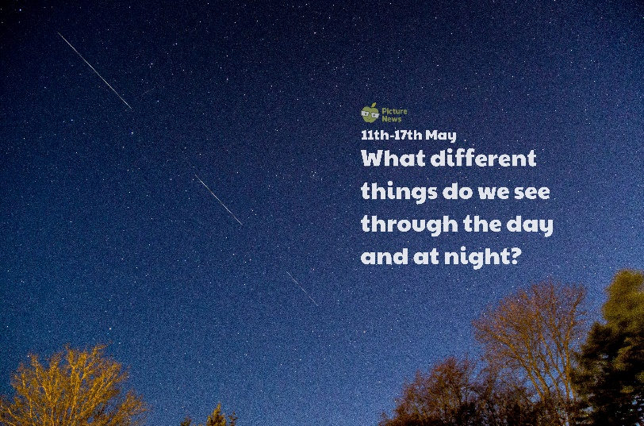

**Use this sheet to let a grown-up write down all your thoughts on this week’s story.**

* What can you see? What do you think the lines in the sky could be?
* What is a satellite?
* What else do you see at night when it’s dark?
* What might you see during the day that you don’t see at night?