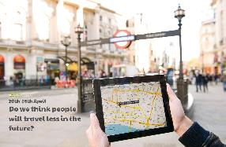

You can still travel to the shops to get food. Imagine that this week, you are in charge of this food shop! Write a list of all the items you would purchase. Can you find out how much each of your items costs? How much will your shopping list be in total?

Can you find out how sound travels? Does how loud or soft a sound is affect how far it travels?

**Learning from Home**

Use the ideas below, alongside this week’s resource, to support your home learning.

Imagine you are going on a journey. You can travel anywhere you want! Think about where you will go, how you will travel there, who you will go with, how long it will take, what the journey will be like. Describe your journey.

Design and make a junk model of a mode of transport e.g. car, train, aeroplane or bike. If you prefer, you could imagine what a vehicle in the future might look like and create that!

There are many ways to travel. How many different ways can you find to travel using just your body? E.g. hopping, jumping, running, skipping. Can you travel using two hands and two feet? What about two hands and one foot, just two hands, no hands or feet? Explore.

Create a map. This could be a map of your local area or a treasure map! Perhaps you could get someone in your home to use the map to find some treasure.