St Ives Infant School



Trenwith Burrows

St Ives

Cornwall

July 2020

Dear Parents/Carers,

End of Year

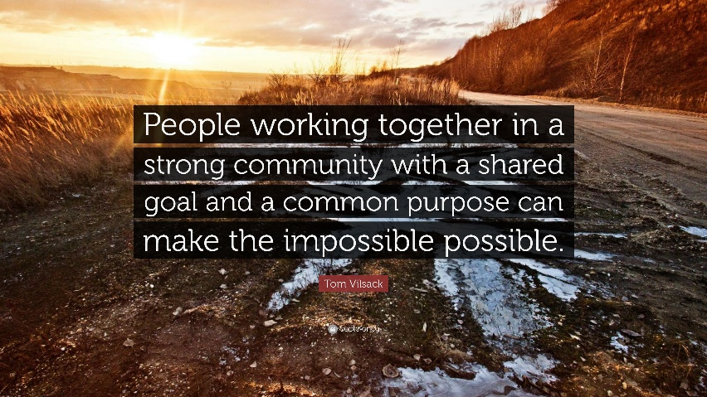

I think I speak for us all when I say – “What a Year!” However, the quote above really resonated with me not just about COVID but in terms of my first year here at St Ives.

On a personal note I had a big long ‘to do’ list to action when I started in September. These included moving 400 miles, finding a rental home, then a new permanent home, relationship building, premises improvements, staffing, curriculum development, systems, policies, appointing new staff and most importantly getting to know almost 200 new little people, their names and their families.

As a school team we have faced some challenges this year, not least a worldwide pandemic! However, what we have is a shared goal – that the children who are part of our school community are **the** most important thing – everything comes back to them and their families. Their wellbeing, emotional and academic development is paramount and every one of the team wants to ensure they all reach their full potential in life. To do that we aim to give them the best possible start. We have worked on so much this year and I would like to say a heartfelt thank you to all the team here at St Ives Infant & Nursery who have rolled their eyes at me many times, but have given things a go and achieved so much together.

As this year is finishing in a very different way to normal I would like to share some of our achievements with you, many include you as our wider community and it is really important to take stock and reflect on what we have achieved together, particularly when we are in such challenging times.

**2019 – 2020 Roundup!**

* Introduced the Green Charter (we will be developing this much further next year)
* New school council formed
* Compost cadets recruited
* Vandalism quashed thanks to persistent reporting, FOSIIS and parental support to purchase CCTV. The police have cautioned two individuals in relation to some of the incidents.
* Strengthened relationships with the Junior School – including shared Inset days, training & networking
* Reduction in lates – thank you for your support with this, it makes such a difference to our children to be here on time, ready to learn with their peers.
* Potential hazards around the site removed in line with Health & Safety inspections – this included the play equipment. We have already had a site visit for potential replacements and are just awaiting the costings and plans so we can share with you (exciting!!)
* Our Setting Sail Curriculum completely redesigned to reflect the rich cultural heritage and opportunities on our doorstep. It now genuinely reflects St Ives, offering more relevance to our children. This will be available soon on our website so please do take the time to read it, we are very proud of what we have created and just look forward to usual business resuming so we can explore it with the children.
* New community members joined our Governing body
* FOSIIS events including the Christmas Fair, Cake Sales, Uniform Sale, Bags2Schools and the silent disco raised over £1,600 in total. The Friends team are a small group of parents, so in just less than half the year, this is amazing, we are extremely grateful to the difference they make to our school and our children.
* £215 raised (so far) via a fundraising page set up by an up country St Ives Lover. Some of this has already been spent on a wide range of books to support our new PSHE curriculum. I will be sharing photos on Facebook when they have all arrived.
* 14 Bid applications actioned for projects around school such as a wide range of outdoor equipment, building improvements & books
* Recruitment of more reading volunteers
* Lots on internal systems and procedures reviewed and refined
* My personal favourite, as it took up so much of my time when I first started, – New boiler funding secured and new boilers successfully fitted!!
* Facebook and You Tube accounts opened and developed
* Computing and PSHE curriculums redesigned
* New Assessment system
* We have seen real commitment to our children from individuals who have had to step out of their usual role to cover for significant absences. Children have shown great resilience in responding to these unfortunate changes. Parents have also been incredible supportive, understanding it was unpredictable and difficult to cover. I really appreciate your support and understanding with the difficult situations we have found ourselves in.
* New steps to the Elliot building

**Lockdown Extras** –

* Many staff have worked hard on ensuring our areas around school have been audited and new provision ordered. We have cleared out so many areas and feel organised and ready for the New Year.
* Preparation for learning in September
* Teaching staff have continued to communicate with parents during this period and keep in touch with all of our children
* Technological abilities, and potentially patience was tested with staff accessing online training and meetings via Skype, Teams and Zoom
* Welfare calls, meetings and home visits have been completed
* We have seen our Pupil Premium eligibility rise by over 10 families. This highlighted that although all of our children receive universal infant free school meals it is important to complete this application for both your family and us as a school. Every eligible child brings £3200 extra to the school funds which we carefully budget and manage to ensure maximum impact for all children. It also means that in times of need we are able to support these families as we have been doing throughout lockdown.
* Many support staff have been working very hard on our outdoor areas with the Early Years Quad, Nursery and other areas getting a mini make over.
* We loaned all of our large pots and pans to Pels who have been doing amazing work providing food for so many of our local community. We also donated a huge amount of frozen food to the Salvation Army, who are working so hard supporting families.
* Staff have undertaken online training with all staff completed at least 8 courses including ones focusing on preparing for welcoming our children back and offering appropriate support.
* We have successfully secured government funding to increase our online presence, training is due to be shared later this month.
* The barriers should be back up and running soon. As you recall these were vandalized some time ago and lockdown has hindered their repair. Access for exceptional circumstances, ie mobility can be discussed with us and a permit allocated if needed. The old fobs will not work.
* Filmed a wide range of videos including stories, modelling strategies and filming soundbites to aid transition for our new Reception parents. Not everyone is comfortable in front of the camera so this is also quite a challenge.
* Our Governing body have been available to attend meetings to enable ‘business as usual’, in fact we have had far more meetings than usual. I do wish to thank them as they are a voluntarily board, here to support school and have given up so much time and been so supportive in this time of lockdown.
* Polytunnel area

During wider reopening Mrs Briggs has been working on the polytunnel area which had become very neglected and overgrown. We are very thankful for the time she has put in and her work is clearly evident. We are all feeling enthusiastic about how this area can be used to its full potential by all of our children. It features heavily in our new curriculum. Mrs Briggs is now moving onto the outside of the Elliot Building and other planting areas.

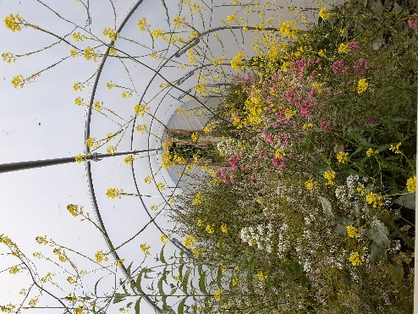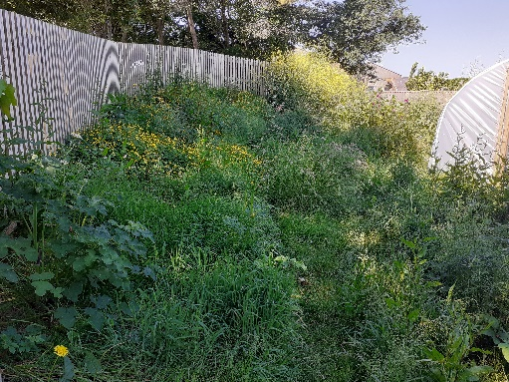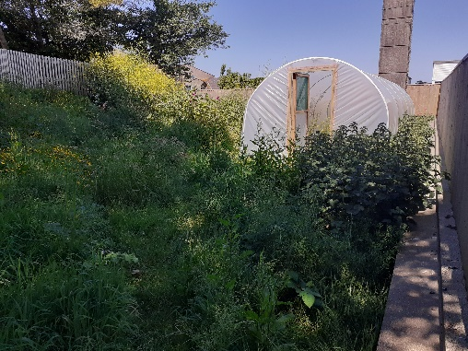

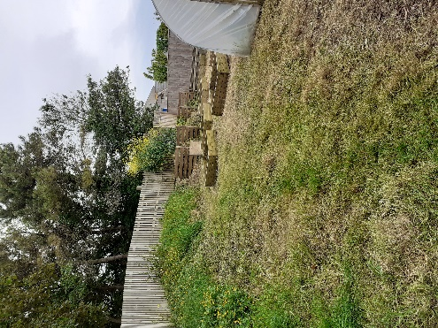

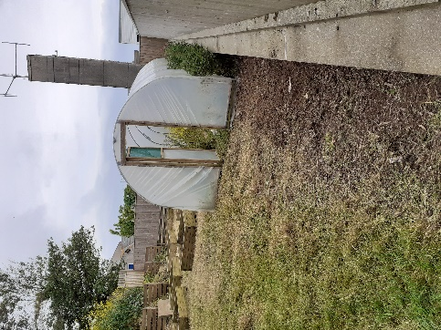

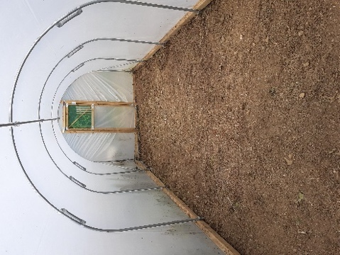

* Mr Farrar has also been voluntarily recruited and has;
* Painted the following - Nursery, Art Room, Jubilee Room, School office, Entrance corridor, Staff room
* Repaired the outdoor shelter to the front of school and the quiet area gazebo
* Cleared the roof and guttering across all buildings

He has also repurposed 4 large old whiteboard screens into outdoor blackboards which will be fitted in the forthcoming weeks.

Staff have worked flexibly across school, in different places, at different times to provide care to key workers throughout the ‘closure’ to all pupils. They have worker remotely ensuring all our families have what they need in terms of educational ideas but also supported people more widely. Staff have also worked flexibly during wider reopening so we can safely meet the changing needs as per government guidance.

**Parents and children have been fantastic!**

There is such a variation in how parents have worked due to your own unique circumstances. I hope you feel you have had access to what you need to work in a way that fits with you. We have heard so many lovely and inspiring stories of families who have really embraced this rather unique time and have found new ways of learning – taking the outline provided by teachers and building it into busy days, whilst juggling jobs, and other children. Quite amazing when you stop and reflect! Some of you have gone BIG with huge ongoing projects taking off to include all subject areas.

Let’s not forget there will be families who have found this a real challenge for many reasons. All of our children will have had different experiences during this time and that’s okay! Many of you, like us here will feel you’ve been on a rollercoaster ride you never chose to get on. At times feeling you had everything sorted and others where things just felt completely overwhelming. I have spoken to so many people who have felt like this over these challenging months and I think we all have to accept that’s okay too.

What we have seen with the children who have returned is how resilient and adaptable they can be. We as adults often consider what the impact of change is on our little people but that is often our perception of change not theirs. The environment we have had to offer was particularly difficult for me and the staff. It is not what we want to provide and we felt that would have huge impact. I think we have learnt the children were glad to be back in some familiar routine, still hung their coats up in the same place and quite enjoyed the excitement of being in school and it being different. Parents have commented on how children have made friends with different people who perhaps they wouldn’t have had the opportunity to mix with in usual circumstances as they would have stuck with the same small group. I have seen children walk themselves up the classroom doors, saying bye to parents with confidence and enjoy these differences. That is not to say there will not be children that will have found this hard and we do not underestimate the impact of that. What I can assure you is that the physical, social and emotional needs of our children is a priority when we fully return. That will not be instead of education, it will run alongside with all staff responded to the needs of individuals. When we finally get our school family back together we will see where our children are, and plan accordingly for all elements of their needs – it’s what we do.

**Looking Forward**

**Premises** - Our 2020 – 2021 aims are to continue upgrading our surroundings so they reflect the love and care that our staff have for our children and families. This will include;

* All outdoor sheds and shelters
* New notice board to the front of school
* Play Equipment (Funding still to be confirmed)
* EY Quad area
* Nursery Area
* Quiet Area
* Growing Area
* The Eliot building
* Fire upgrades to the building and surroundings areas (markings, signs, equipment etc) - (Funding still to be confirmed)
* Internal heating upgrades (Funding still to be confirmed)

**Uniform**

We are moving to an online stockist for our uniform as we feel they offer more accessibility and value for money for our parents. Their website can be found below and our school offer is due to go live in the next couple of weeks.

<https://myclothing.com/>

I would also to take the opportunity to remind parents that plain uniform in our school colours is part of our uniform. It is completely your choice whether you have a logo embroided onto uniform pieces.

We do still have some stock available via the office although this is limited, as once it has gone we will no longer have stock in school, only via the website or usual outlets (plain uniform).

**Payments**

With effect from September we will be moving to a website and app called School Money to handle all our finances coming into school. This allows parents/carers much more accessibility and keeps everything in one place. This is the same system the Junior school use and you can add your child with us, onto the same account you already have so all your information is in one place. It combines information and cost all in one place. You can access your account at your convenience see if you up to date with payments or if there are any outstanding. It allows you to give permission for trips, read and revisit key trip information and pay all in one place. We will continue to have water bottles and book bags available in the ‘school shop’ which allows you to buy via the app then collect from school for these items. We are aiming to be as cash free as possible. All information will be sent out before the end of term.

**Swimming**

At the time of writing, it seems extremely unlikely that swimming will be taking place next year due to safety measures that may still be on place. The current circumstances mean we are unable to book for our usual lessons as no one knows if this can go ahead. If things change, we will try to at least book for our Year 2s in Summer term. We will of course keep you updated.

**Reports**

We know how valuable yearly reports are so despite our early, rather sudden end to the year, class teachers have still prepared reports for all of our children. They provide a narrative of your child’s journey in school and throughout lock down. They are truly lovely and really capture the nature and characters of our children. I am in the lucky position of been able to read them all and it was an absolute joy: I smiled, giggled and may even have experienced a tear or two - I know you will love them! Thank you to the teachers who have managed to fit these in, between all the new tasks they have taken on during lockdown.

**Summer Food Fund**

The government have recently confirmed they will support families over the summer holidays. Those families eligible for Pupil Premium funding will continue to receive vouchers from the Edenred scheme. One voucher for £90 will be issued at the beginning of the holiday.

**Year 1 and Year 2**

At the beginning of this lockdown I never envisaged we would be in a position where we were unable to welcome back our year 1 and 2’s back for some part of this year. However, as the guidance was released and updated it became evident this would not be possible. Due to staff all been in bubbles, sadly, this is still not a possibility even for a short amount of time.

Year 2 will receive a book token within their report pack for them to spend at St Ives Book shop on a book of their choice, which would usually be gifted at the end of the year. This is funded by FOSIIS.

**September**

Unfortunately, and rather frustratingly, we do not yet know what September will look like as we are still awaiting government guidance. We are working on several different scenarios which makes it difficult to confirm all adults in classes. However, we can share class teachers which you will find below.

Pipit – Miss Sturges Heron – Mrs Hicks

Puffin – Miss Saunders & Mrs Bason Kittiwakes – Mrs Pulley

Chough – Miss Singh Sandpiper – Mrs Thomas

Cormorant – Ms Lewis & Mrs Phillips

**Staffing**

I am delighted to share the news that Ms Lewis will be undertaking a new role in September as our Assistant Head. She has a wealth of experience across the Early Years and Primary phase, has taught within several schools and has previous leadership experience, so I know she will be a great asset to our school as we continue to evolve.

Mrs Thomas will be joining us in Sandpiper Class as the Year 2 teacher next year. She has worked so hard this year to ensure there is some consistency for the children in Sandpiper and shown a great deal of dedication to our children. She has been a full part of our school community taking on wider responsibilities and has written some really detailed reports for the children. We are absolutely delighted she will be joining us on a more permanent basis and welcome her back to the St Ives team.

Mrs Ralph a valuable member of our cleaning team will be leaving at the end of the year. I understand she tried to retire once before but found herself working back at school in a very short time. She tells me she is definitely leaving this year but I guess time will tell…

We all wish her all the very best in her retirement and thank her for her commitment to the school over the years.

I apologise for such a long letter but it is my aim to update you as much as possible. I also really wanted to share all the positives in such a challenging time, as there are many. I will be in touch with you all again very soon with further details on the arrangements for September.

Take care and stay safe,



Leisa Farrar

Headteacher

**Website** - <https://www.st-ives-inf.cornwall.sch.uk/web/home/190040>

**Facebook** – St Ives Infant and Nursery School

**You Tube** – St Ives Infant School