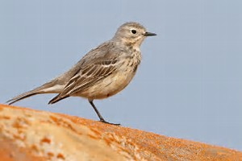
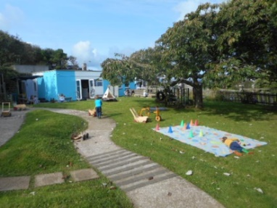
Pipits Weekly Update!
11.2.2019
During this week’s outdoor group time we looked around the garden for items to stick onto our nature bracelets. We found leaves, sticks, grass and some lichen to decorate them with.
- We have been practising counting by choosing a number and clapping. You can try this at home with dice. Roll a dice and clap the number they have rolled (5= 5 claps)
- This week we have been reading a story called. “Bee. Natures tiny miracle” Which tells the story of bees helping to pollinate the environment.
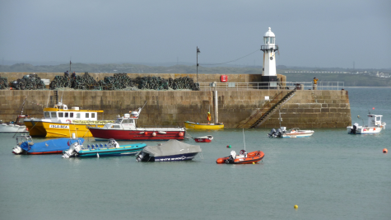
At Home
- Next week is half term! We return to nursery on the 25th February. Please remember we love to hear about what you have been up to; so if you go anywhere please bring in some photos so your child can talk about where they have been.

Pipits Weekly Update!
5.2.2019
- This week we have had our first outdoor group time. We sat together on the logs and sang our welcome song
‘Hello everyone how are you today?
Very well thank you we’re okay,
we’ve just begun, it’s time to have some fun
with outdoor learning and play!’
- We then had a go at finding sticks that were smaller than our arm and then turned them into magic wands! The spell we put on our wands made us able to freeze people. We took turns listening carefully to the spell and standing still when our friend said freeze.
- We have also been thinking about how we can be kind to our friends and taking care of each other. The children talked about what they can do to be kind- sharing toys, letting people join in, not hurting others and helping friends to put their shoes on!
At Home
- We are still looking at stories that involve boats. If you have a picture of your child on a boat or by the sea please send it in so we can talk about it (please ensure child is clothed in pictures on the beach- swimsuit is fine)

