

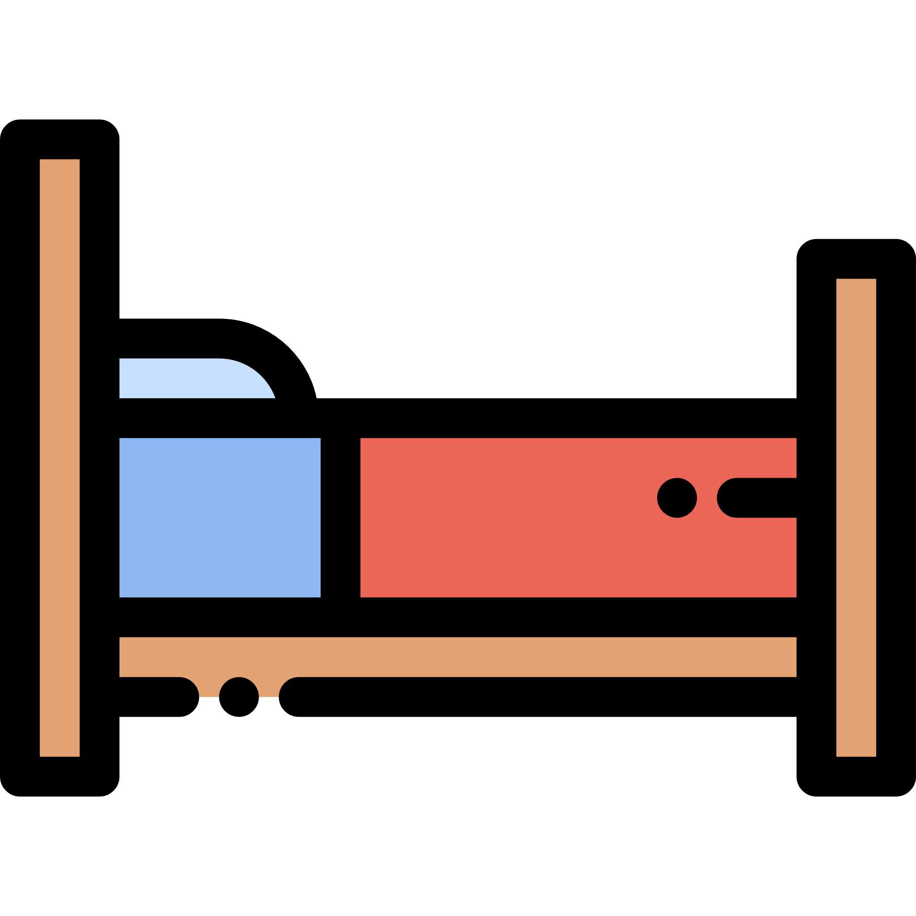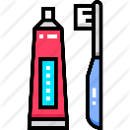

**Routines**

Use the boxes below to draw pictures of some of the things you do each day.



Cut out your pictures and use them to answer the following:

* Which things do you usually do in the morning?
* Which things do you usually do in the evening/afternoon/night?
* Can you put them into an order? Explain why you have organised them this way.
* What do you do first, next, last?

You could keep your pictures and use them to help organise part or all of your day!