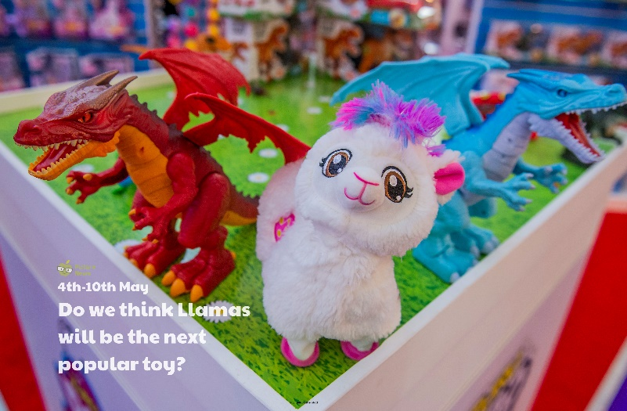

**Use this sheet to let a grown-up write down all your thoughts on this week’s story.**

* What do you like to look at most of all in a toy shop?
* What do you think of llamas? Do you like them?
* What do you like about them?
* Do llamas remind you of any other animal?
* Would you buy a llama toy? Why/why not?