



**My Favourite Toy**

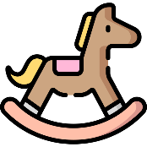

**Picture**

What is the toy? ___________________________________________

What does it look like? ______________________________________

________________________________________________________

When and where did you get it? ______________________________

________________________________________________________

How does it work or how do you use it to play? ___________________

________________________________________________________

Why is it your favourite toy? _________________________________

_________________________________________________________