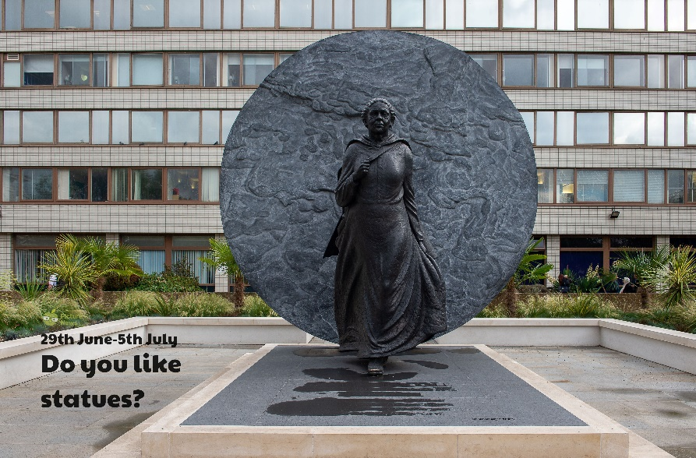

**Use this sheet to let a grown-up write down all your thoughts on this week’s story.**

* What can you see? Who do you think this lady could be? Do you think she might be an important person? Why do you think that?
* Have you seen any statues before? Are there any near where you live, or have you seen any on the television?
* What have you seen? Can you remember where it was?