

**Wild Animal Fact File**

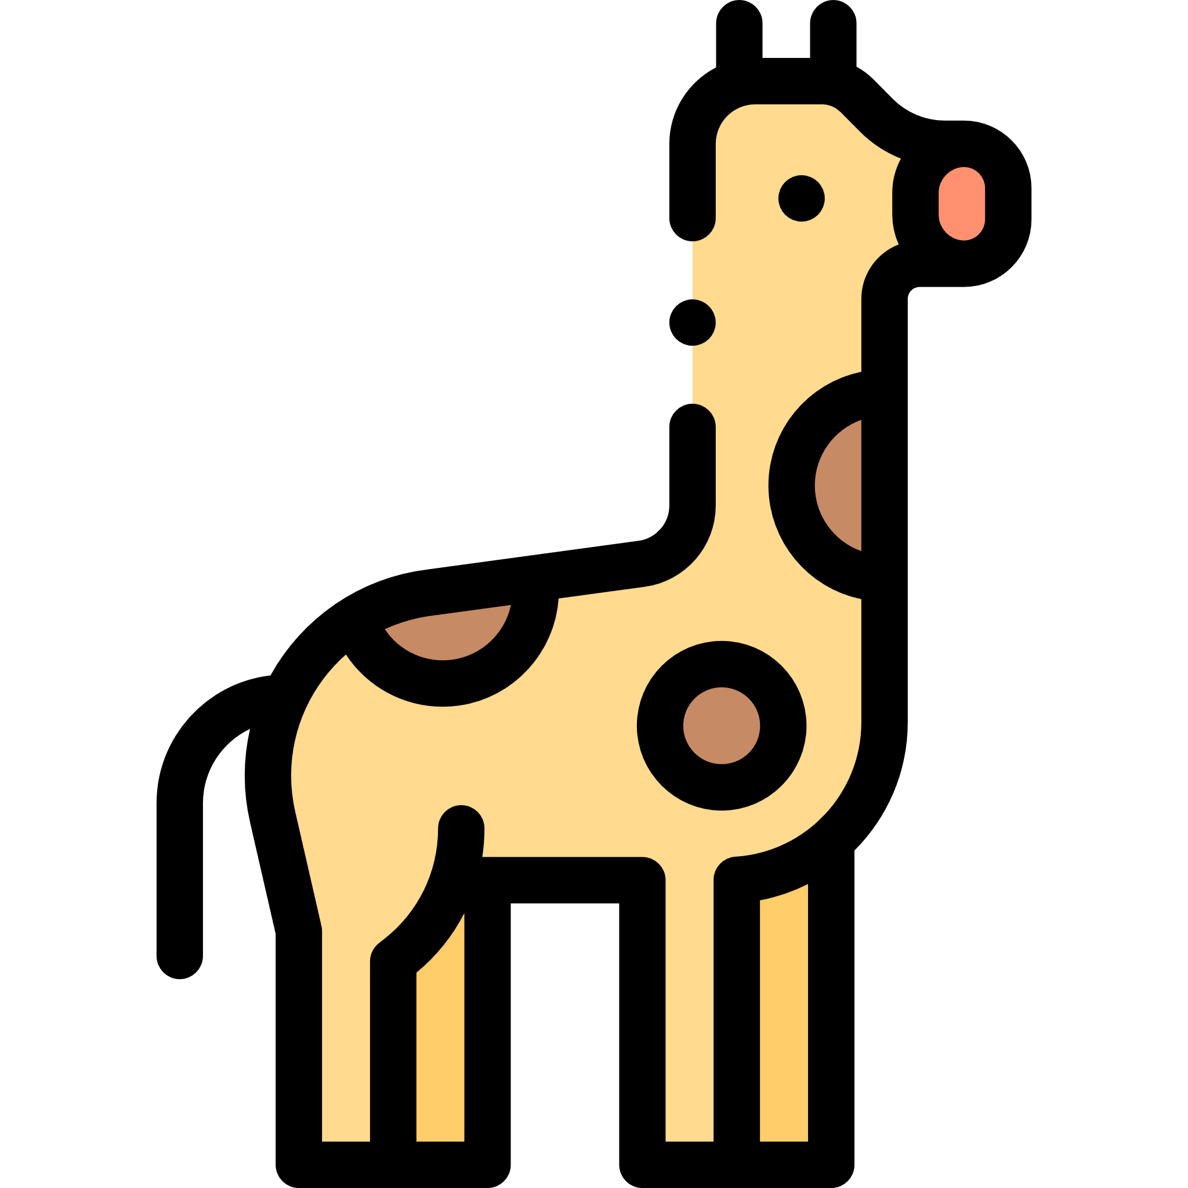

Animal ________________________________________

Where does it live? ______________________________

______________________________________________

What does it eat? _______________________________

______________________________________________

What does it look like? ___________________________

______________________________________________

Any other interesting facts

______________________________________________

______________________________________________

Picture