St Ives Infant School

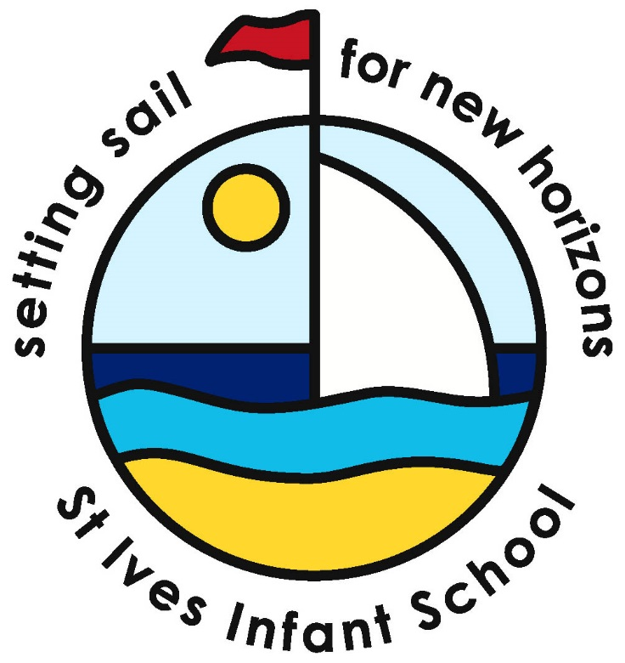

Trenwith Burrows

St Ives

Cornwall

3rd June 2020

Dear Parents/Carers,

Transition

Thank you for your patience at this rather difficult time. I am sure you can appreciate that ensuring we are safe to open for our current children has been quite some task under the new guidance. Hopefully you will have seen our updates on our Facebook page or website.

As things are not going to change significantly in terms of the wider opening of schools in the near future it make sense to go ahead with our plans to complete transition virtually. This will comprise of the following-

* Short videos by the Early Years Team and myself to introduce ourselves and go through all the aspects of transition that we would do at the welcome meeting. These will be accessed via You tube and we will email a link.
* Copy of the Power point will be emailed out.
* Welcome packs will be posted out and available for collection.
* A Zoom meeting to answer any questions.

All of these will be available the week beginning the **29th June**. This leaves us with another 3 weeks of school for you to return forms and ask any questions you may have via a Zoom meeting with the Early Years Team.

Take care and stay safe,



Leisa Farrar

Headteacher

Website - <https://www.st-ives-inf.cornwall.sch.uk/web/home/190040>

Facebook – St Ives Infant and Nursery School