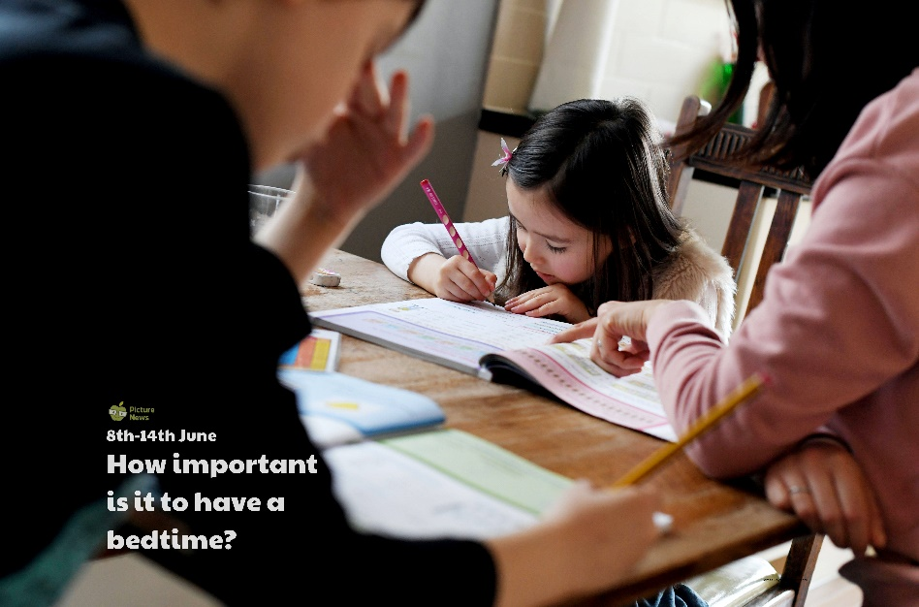

**Use this sheet to let a grown-up write down all your thoughts on this week’s story.**

* What can you see? What do you think this family are doing?
* Did you or are you doing schoolwork at home? How was/is it different from when you are at school?
* Do you do the same things every day? What do you do?
* Did your routine change when you stopped going to school? How?
* What is your bedtime routine?