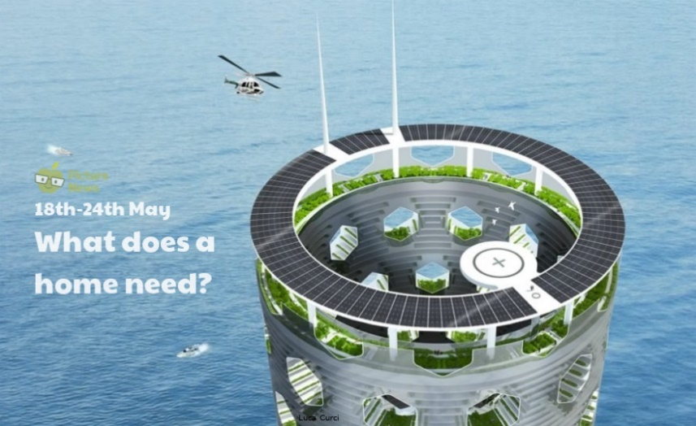

**Use this sheet to let a grown-up write down all your thoughts on this week’s story.**

* What can you see? Does this building look the same as other buildings you see?
* What do you think a home needs?
* How many different rooms do you think each home will need? What do we call these rooms?