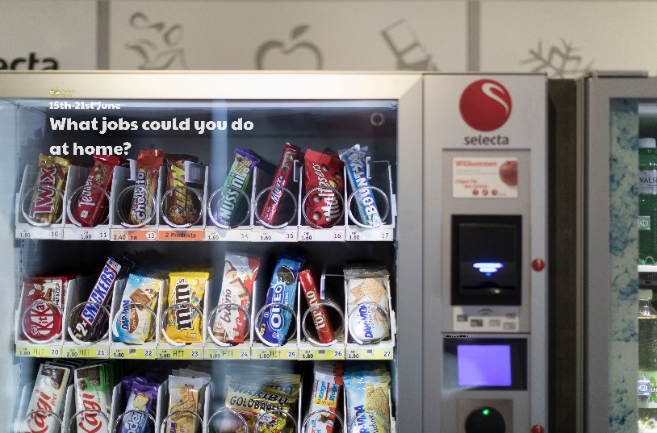

**Use this sheet to let a grown-up write down all your thoughts on this week’s story.**

* What can you see? What is a vending machine? How does it work?
* What snacks do you like to eat at home?
* Would you like to help at home by doing some jobs? What jobs would you like to do?
* Are there any jobs you wouldn’t like to do? Why not?